**Linked Data Framework Installation**

**Note:**

|  |
| --- |
| * This document outlines essential configurations, and for any additional setup requirements, please refer to the document below.   [linked_data_framework.pdf](https://iz.sharepoint.com/:b:/r/sites/PolarionDRXProject/Shared%20Documents/General/Research%20Documentation/Teamcenter_14.2_Installation_Doc/linked_data_framework.pdf?csf=1&web=1&e=KjzWLz)  After installing, the LDF Lis.war file (Teamcenter 14.0) was generated automatically. Upon inspection, it was found to have some bugs. To resolve this issue, I replaced it with my previous version, Tc13.0 Lis.war, which worked perfectly in Teamcenter 14.0.    For those directly installing Teamcenter 14.0, please ensure the mentioned features are present. If any features are missing, please ignore them during installation. After completing the LDF installation, check the integration. If it is not functioning properly  I have provided the Tc13.0 Lis.war file below.  **Please use this war file and replace your hostname** **to the provider.properties file.**  C:\lis.war\WEB-INF\classes\provider.properties  image |

**Facing issue while installing Ldf Feature**

**Shell Command Failed**

**Check shell.err file**

Teamcenter Environment for script execution Updating TC_DATA_MODEL with templates from datasets Downloading File: model.xml 41178: FSC proxy error: "error Code: 7 and error Text = "CURLE_COULDNT_CONNECT: The destination server is offline or unreachable on this network. "Error updating the TC_DATA_MODEL with templates from datasetsScript execution failed.

Errors in file [ DataBase] D:\ORACLE19C\ORA_BASE\diag\rdbms\tc14\tc14\trace\tc14_tt00_8128.trc:  
 ORA-19809: limit exceeded for recovery files  
 ORA-19804: cannot reclaim 104857600 bytes disk space from 4294967296 bytes limit  
 2024-10-23T18:42:15.716538+05:30  
 Errors in file D:\ORACLE19C\ORA_BASE\diag\rdbms\tc14\tc14\trace\tc14_tt00_8128.trc:  
 ORA-19809: limit exceeded for recovery files  
 ORA-19804: cannot reclaim 104857600 bytes disk space from 4294967296 bytes limit

**Root Cause**

Our database recovery limit exceeded

**Solution**

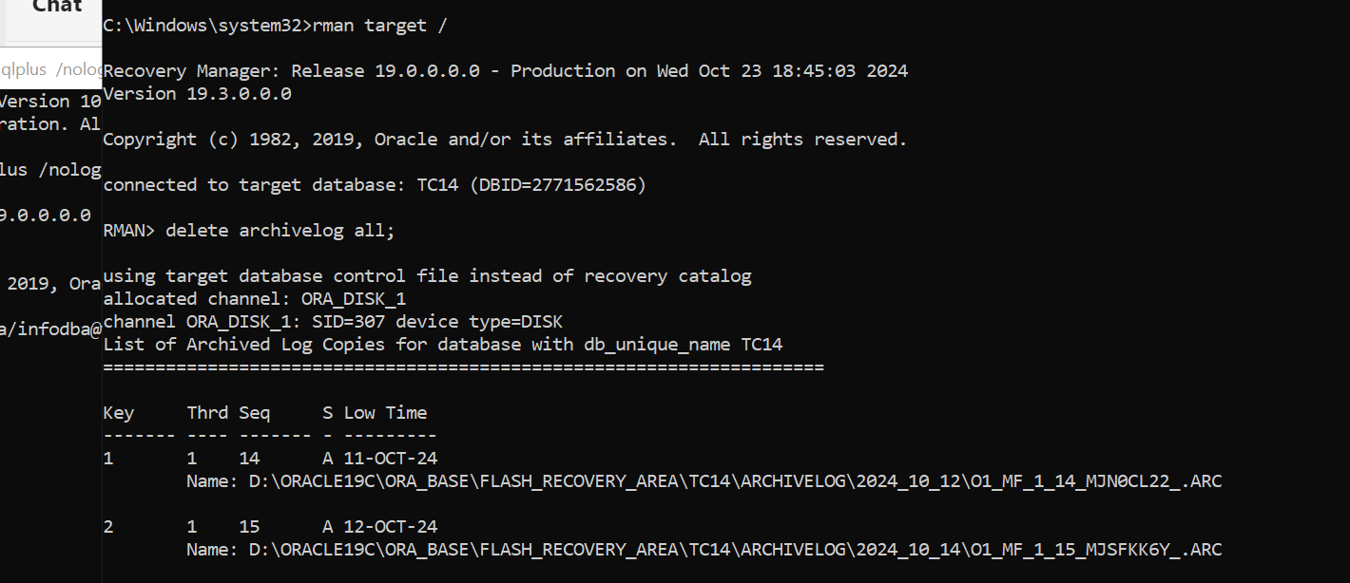

**Install LDF Feature:**

Run tem.bat in administrator in TC_ROOT Directory

n1)Configuration Manager ->Next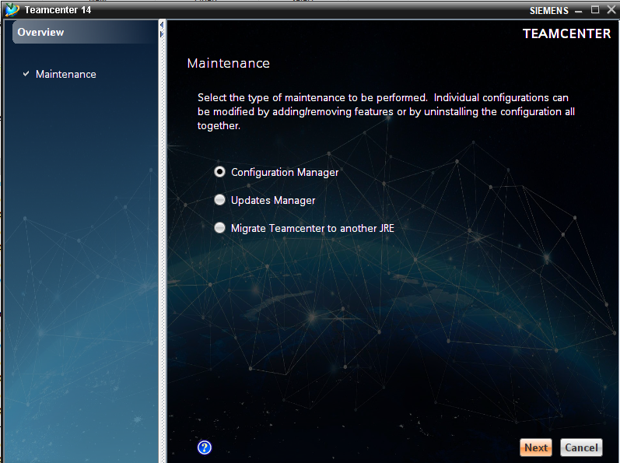  
2)Perform maintenance on an existing configuration -> Next

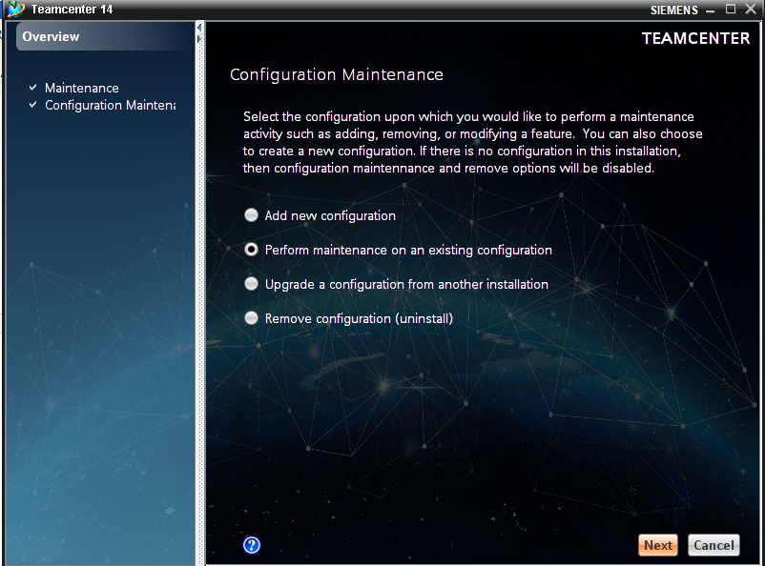  
3)Add/Remove Features -> Next

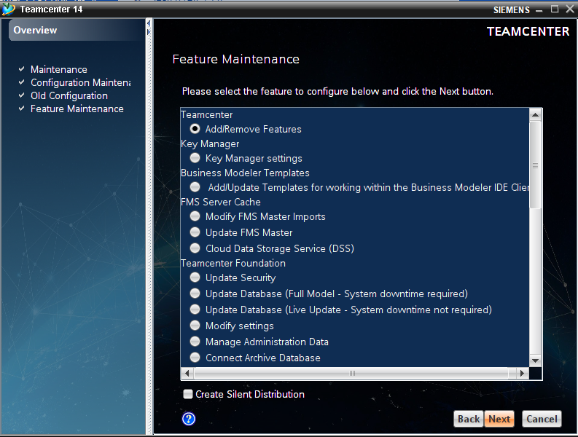  
4)Install Below Features - Next

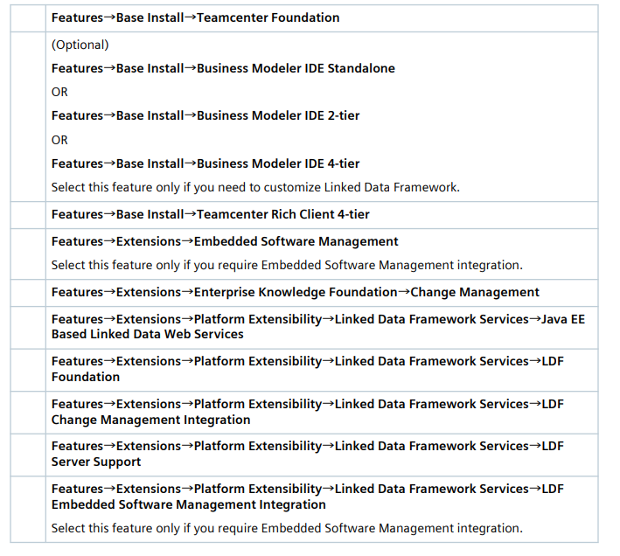  
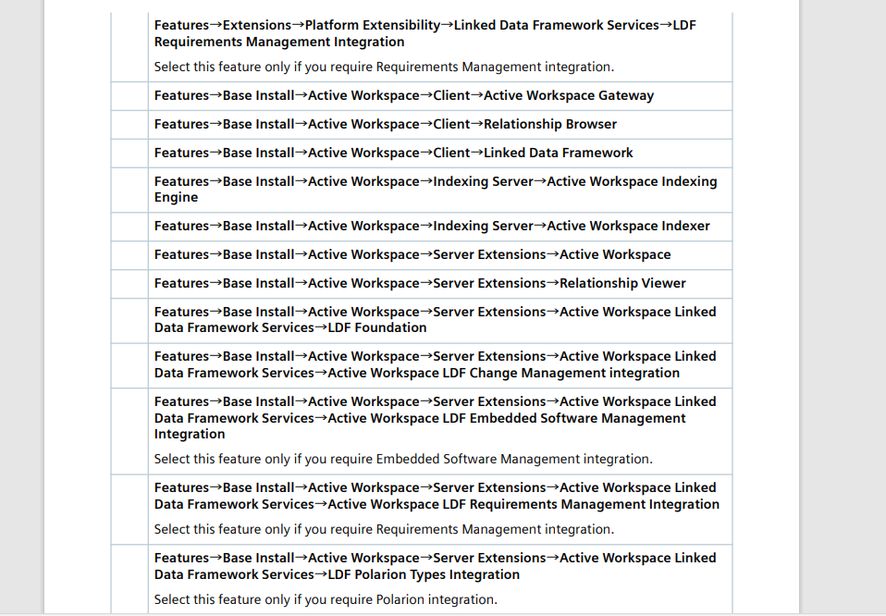

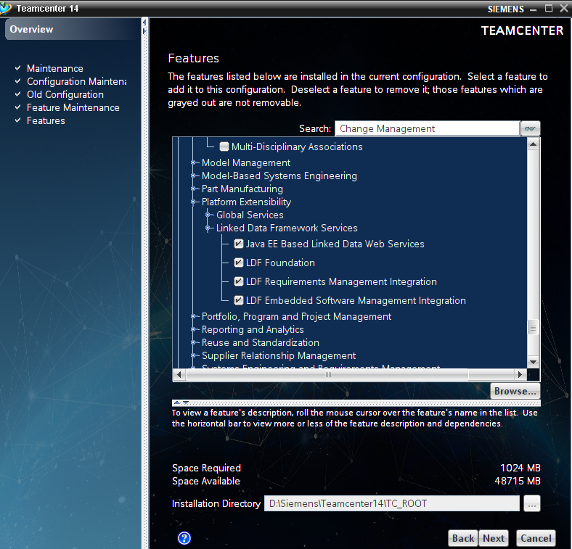  
Below Pic in Teamcenter 14.2 there 3 features not there but mentioned In checklist

* LDF Server Support
* Change Management Integration
* Active workspace LDF Change Management Integration

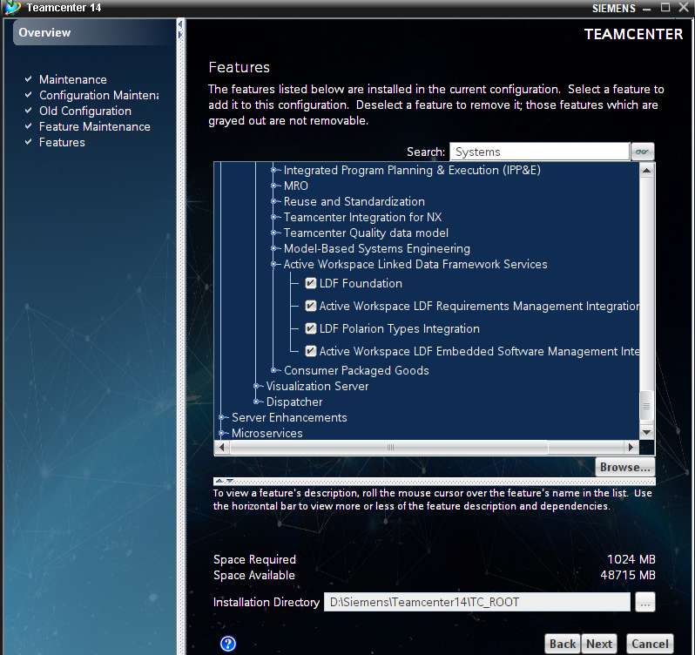

* LDF Server Support
* Change Management Integration
* Active workspace LDF Change Management Integration

In previous version 13 had above 3 features I add this pic below this image

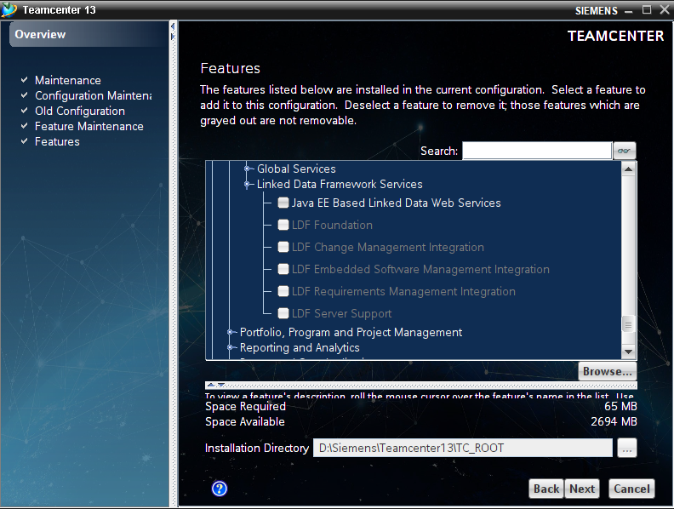  
5)Enter OS User Credential

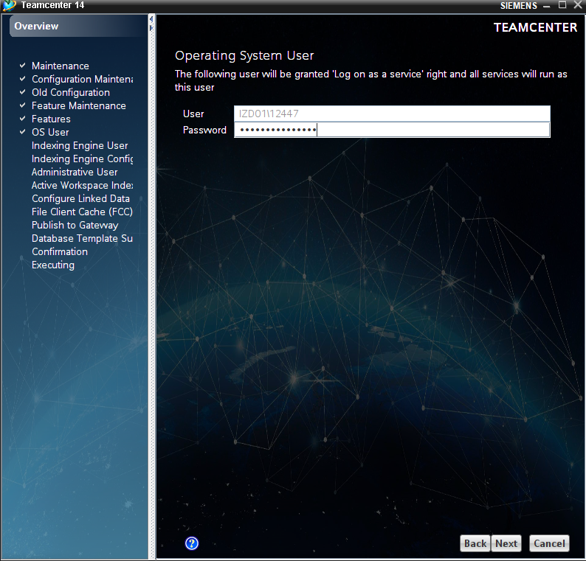  
6) Password: solr_admin

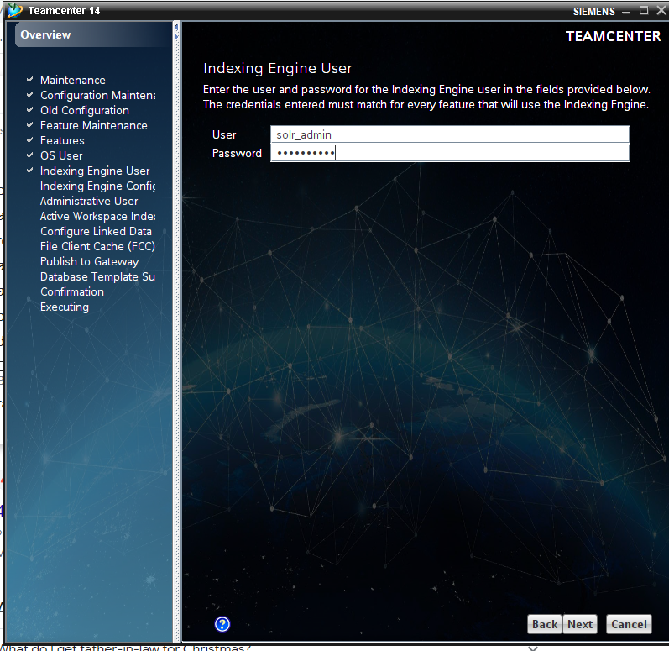  
7)Next

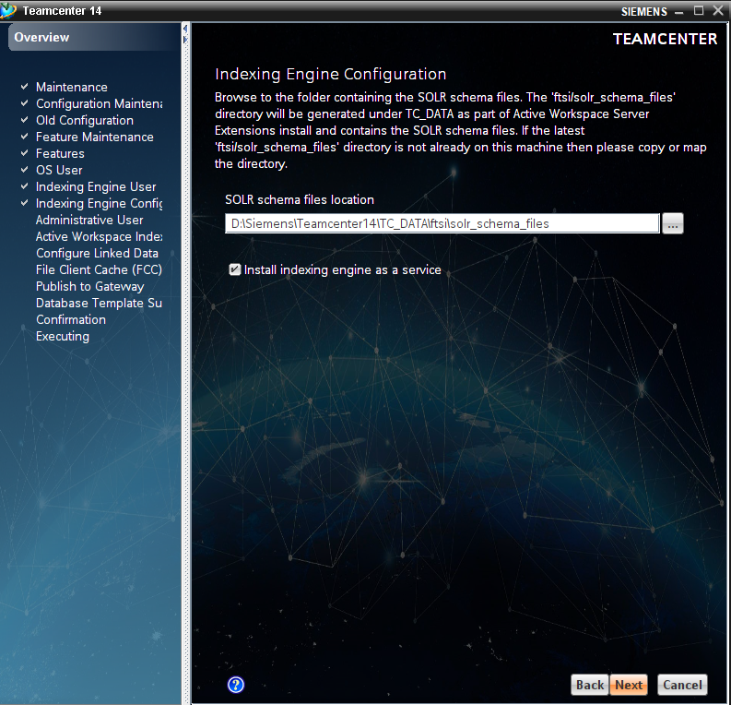  
8) Enter Teamcenter Administrative Credential

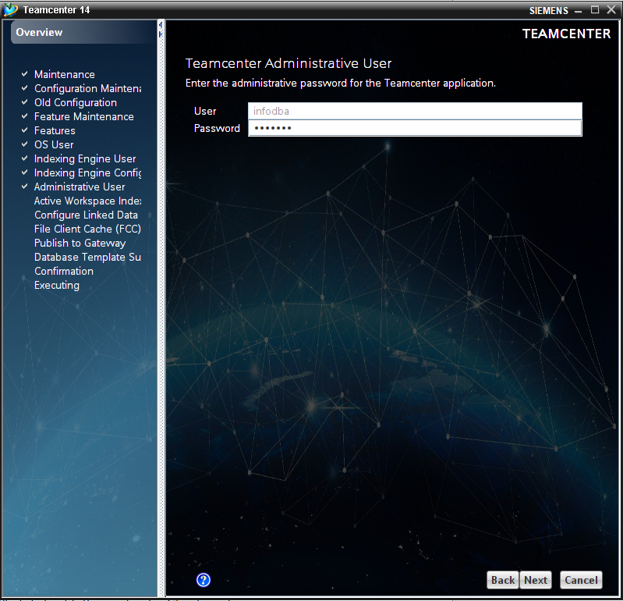  
9) Next

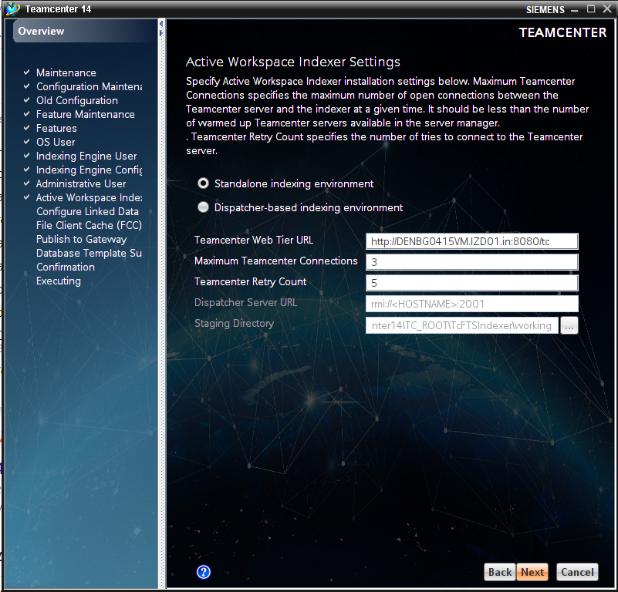  
Ok

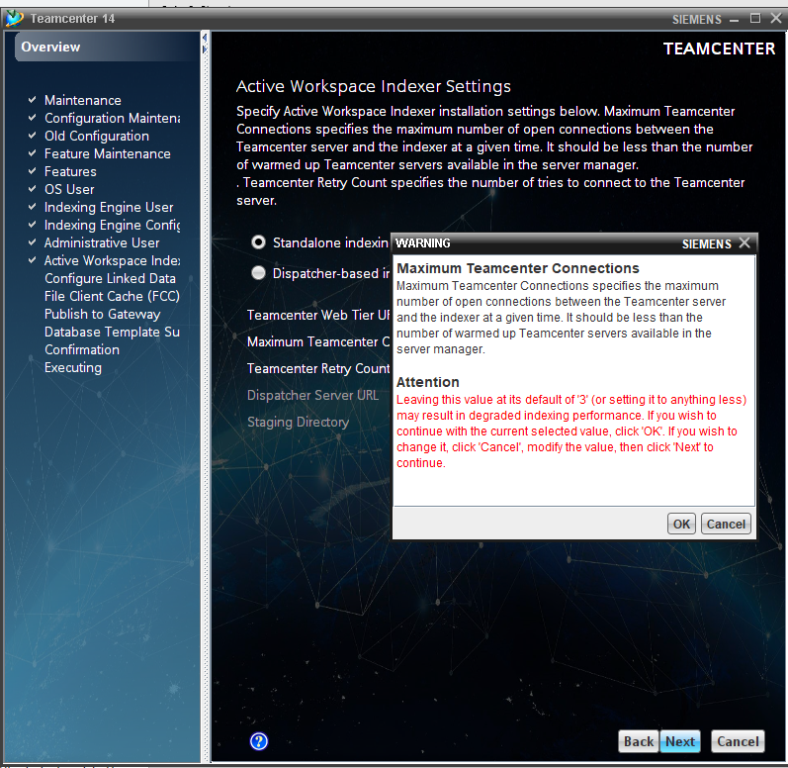  
Infodba

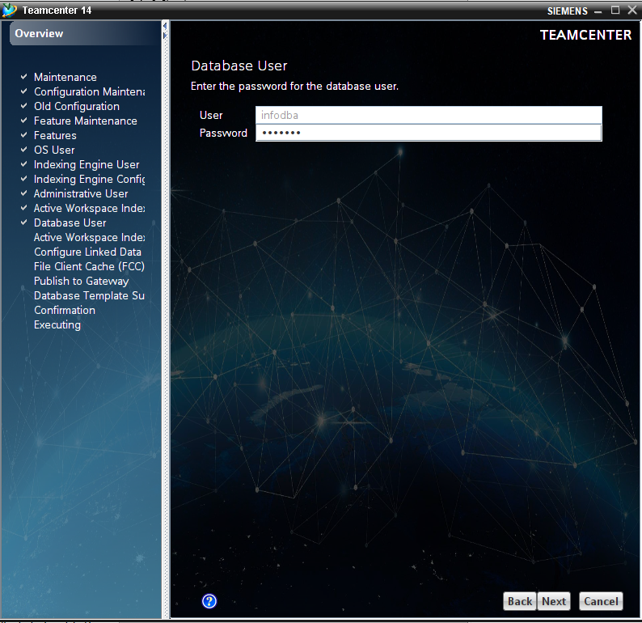  
Check Below 3 indexer

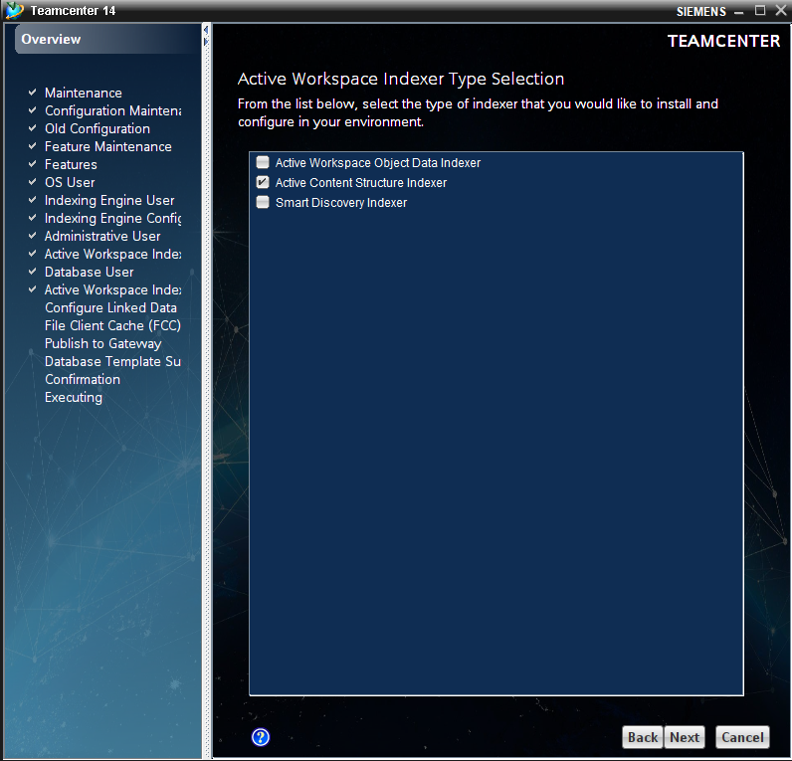  
Provide Teamcenter 4 tier URL

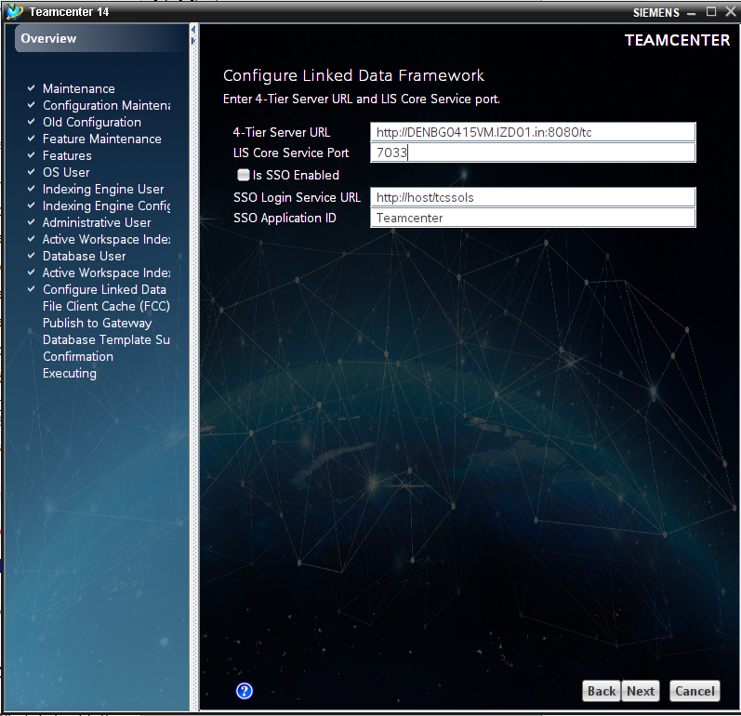  
Use current FCC

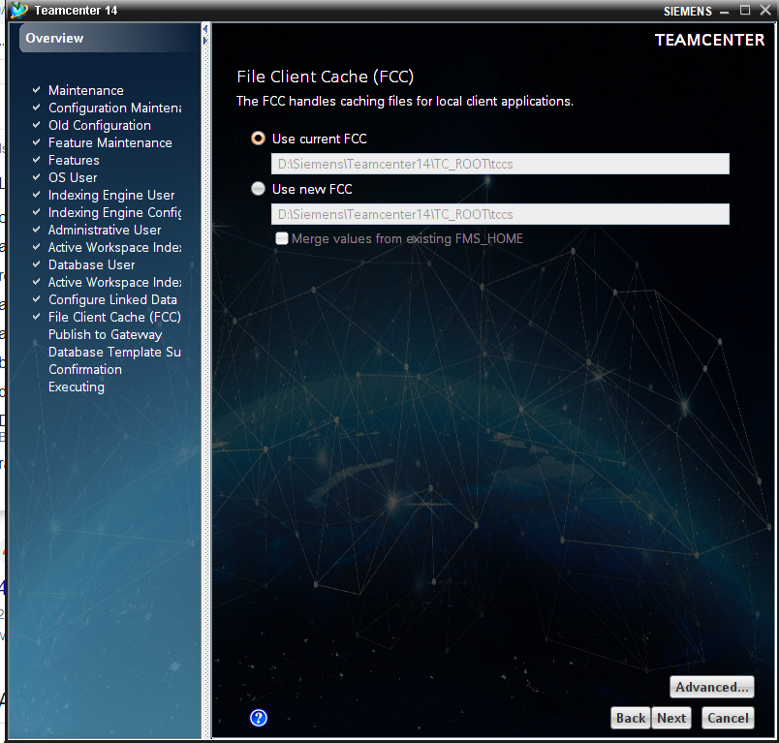  
Next

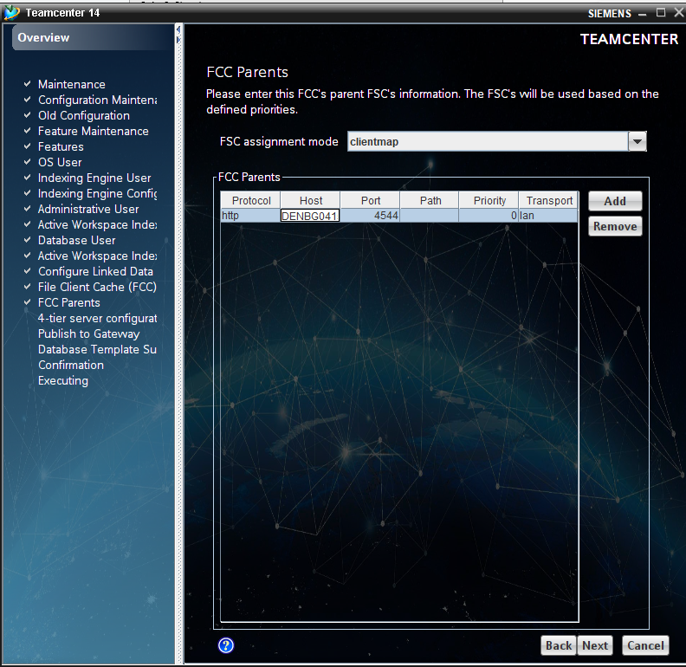  
Next

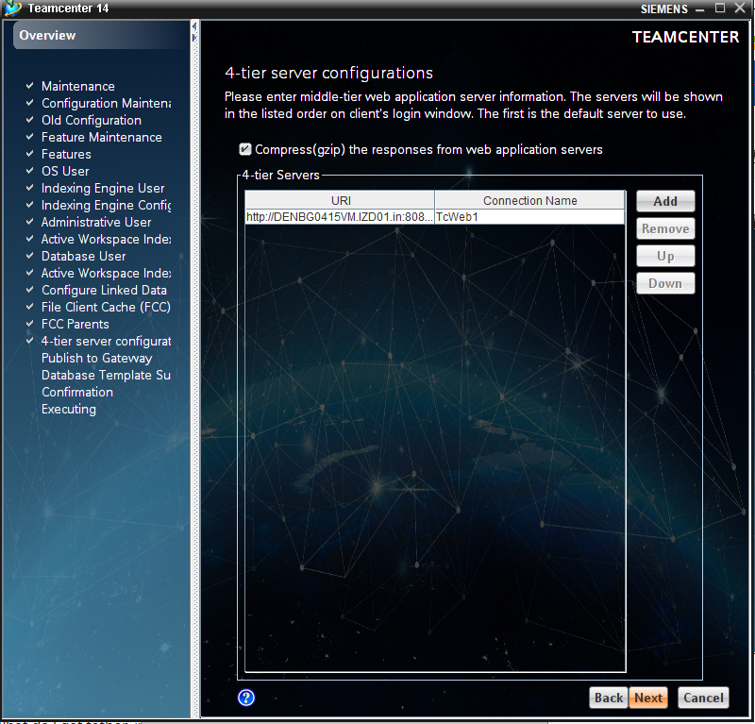  
Provide Gateway URL (Your FQ Host Name)

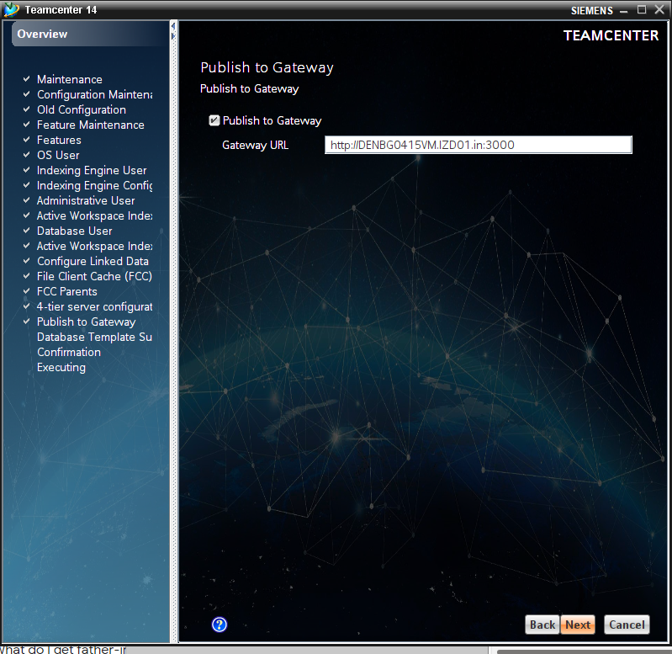  
Check the Template -> Next

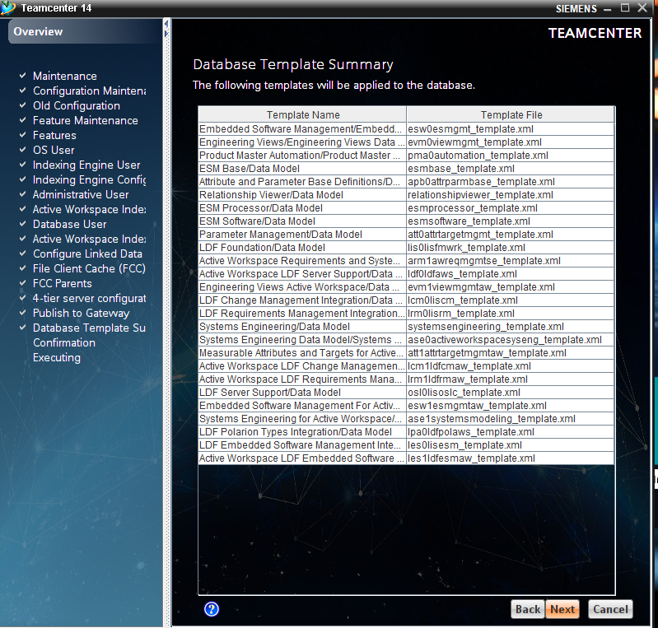  
 Start

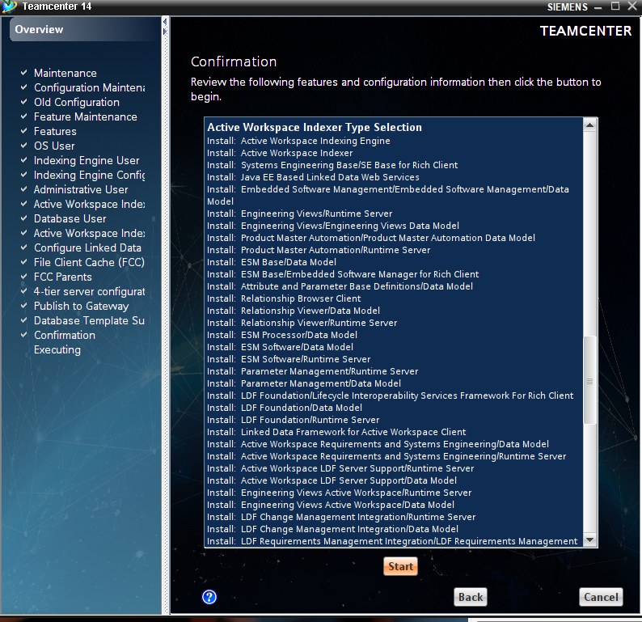

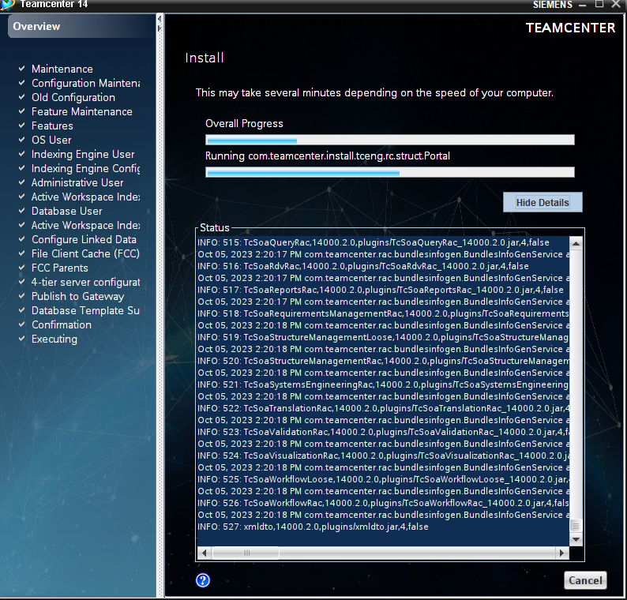  
Installation Complete

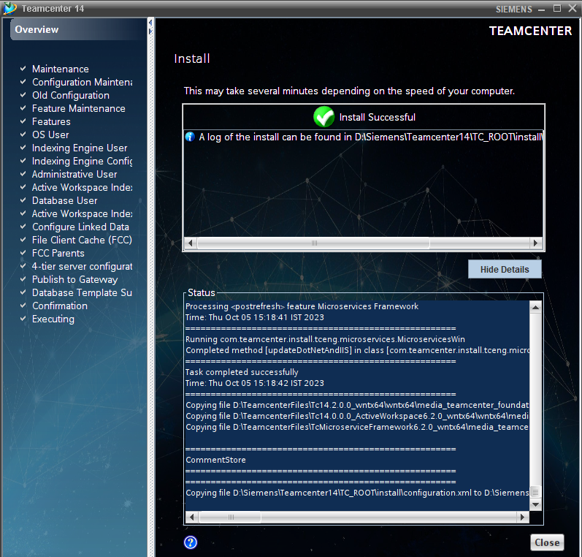

Successfully Installed LDF